Part 1&2
I used Figma for my tools this is the most intuitive tool I have found and makes it easy.
This is a basic mockup:
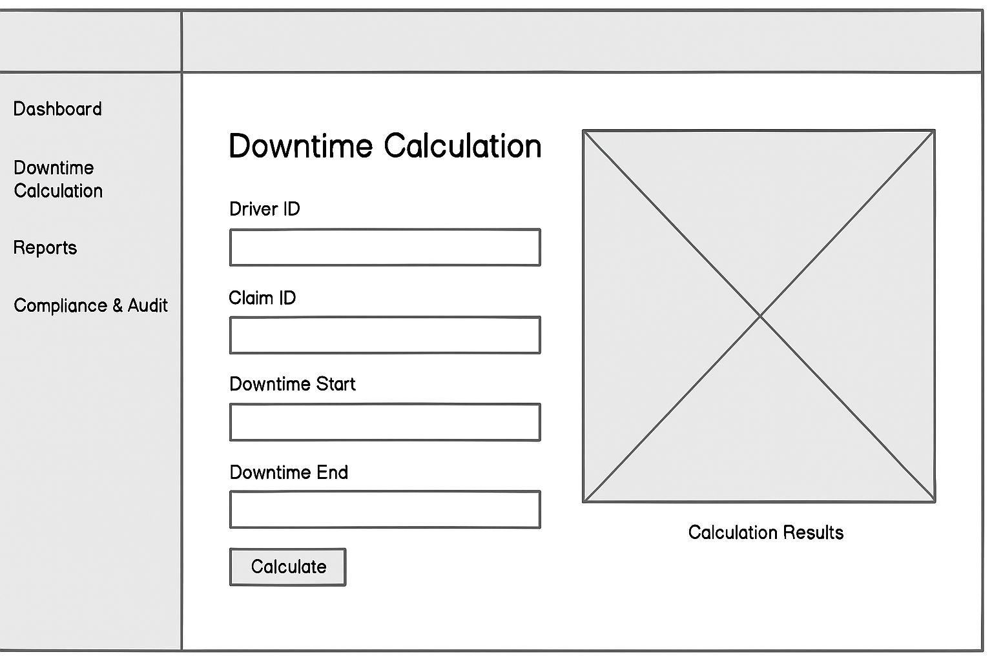
Part 3&4
This is the upgraded application for use in the insurance industry for adjusters.
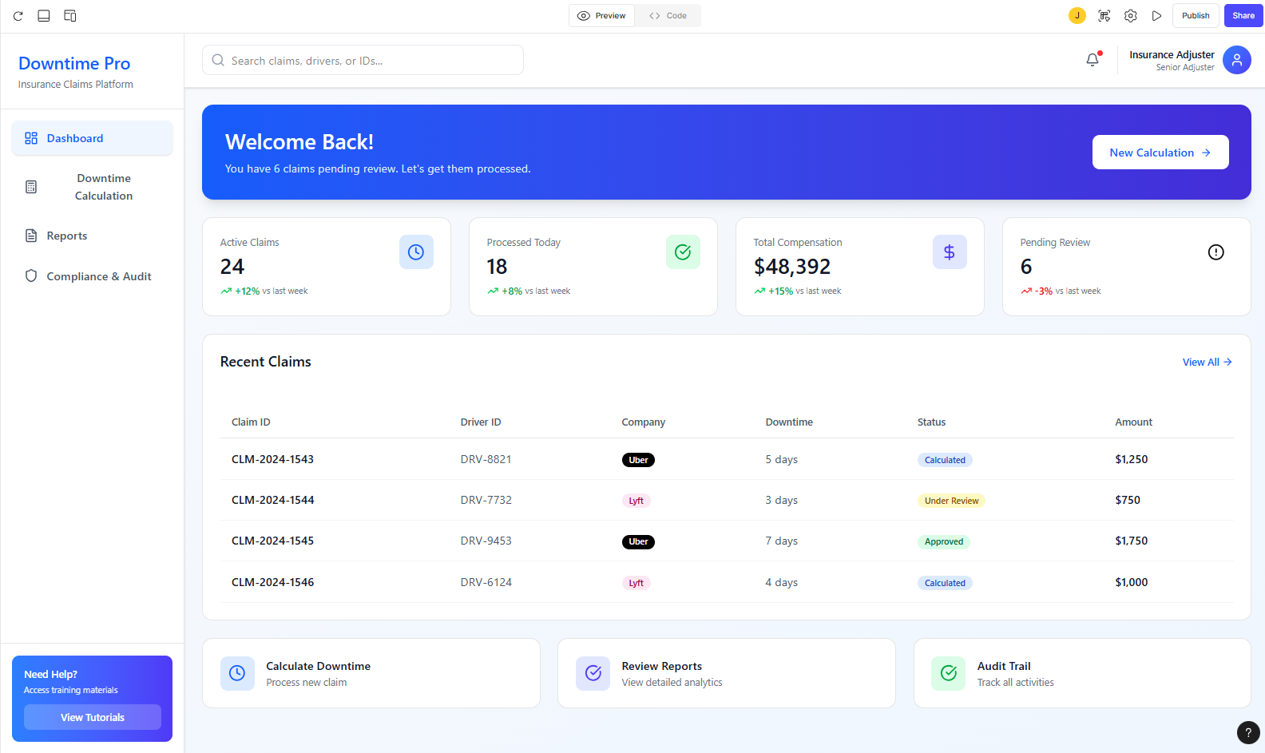
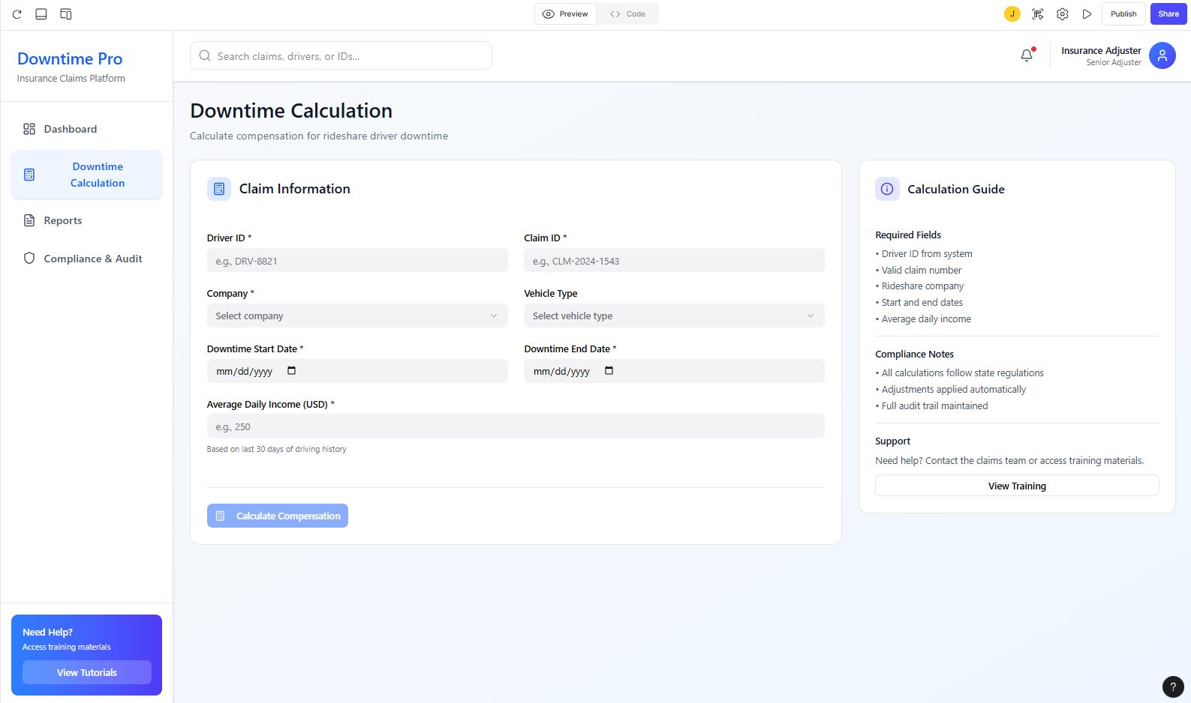
Made the downtime calculator more intuitive and better flow.
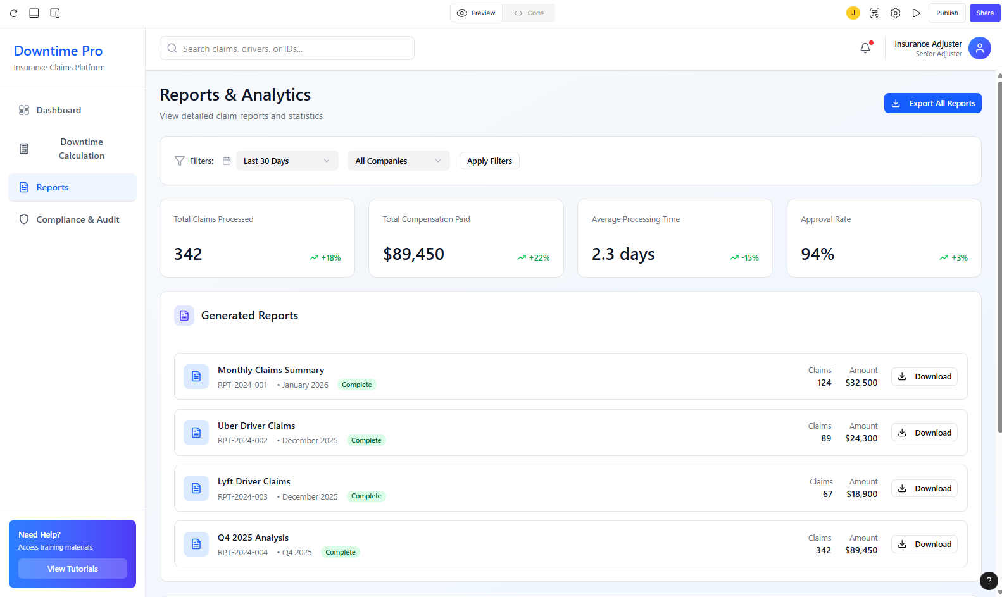
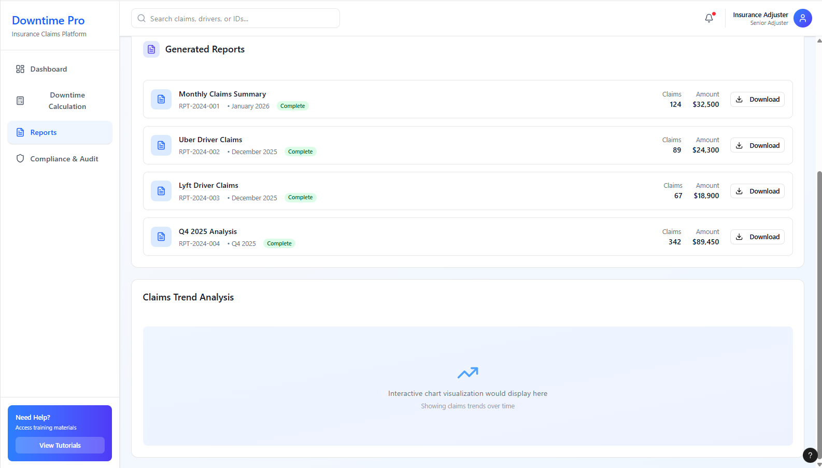
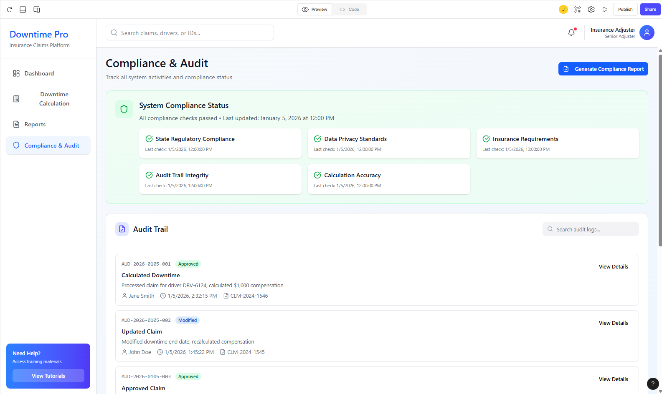
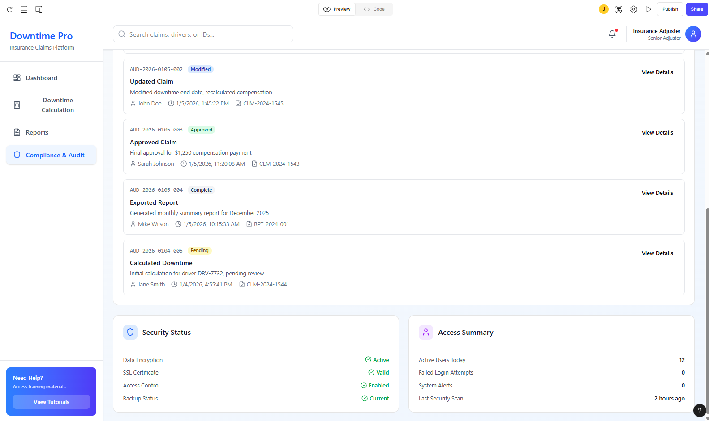
Added the audit tools to make sure that workplans are in line and to make sure compliant with company guidelines.

